**A Novel Method For Handwritten Digit Recognition System**

**1.INTRODUCTION**

Handwriting recognition is one of the compelling research works going on because every individual in this world has their own style of writing. It is the capability of the computer to identify and understand handwritten digits or characters automatically. Because of the progress in the field of science and technology, everything is being digitalized to reduce human effort. Hence, there comes a need for handwritten digit recognition in many real-time applications. MNIST data set is widely used for this recognition process and it has 70000 handwritten digits. We use Artificial neural networks to train these images and build a deep learning model. Web application is created where the user can upload an image of a handwritten digit. this image is analyzed by the model and the detected result is returned on to UI

**Technical Architecture:**

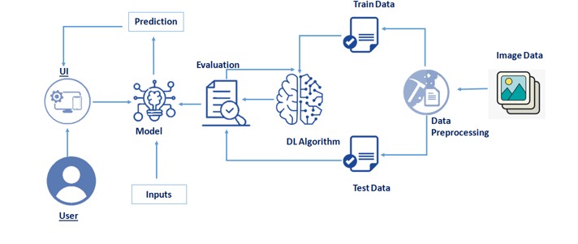

**Project Objectives**

**By the end of this project you will:**

* Know fundamental concepts and techniques of the Artificial Neural Network and Convolution Neural Networks
* Gain a broad understanding of image data.
* Work with Sequential type of modeling
* Work with Keras capabilities
* Work with image processing techniques
* know how to build a web application using the Flask framework.

**Project Flow**

**Project Flow:**

* The user interacts with the UI (User Interface) to upload the image as input
* The uploaded image is analyzed by the model which is integrated
* Once the model analyses the uploaded image, the prediction is showcased on the UI

**To accomplish this, we have to complete all the activities and tasks listed below**

* Understanding the data.
  + Importing the required libraries
  + Loading the data
  + Analyzing the data
  + Reshaping the data.
  + Applying One Hot Encoding
* Model Building
  + Creating the model and adding the input, hidden and output layers to it
  + Compiling the model
  + Training the model
  + Predicting the result
  + Testing the model by taking image inputs
  + Saving the model
* Application Building
  + Create an HTML file
  + Build Python Code

**Project Structure**

Create a Project folder which contains files as shown below

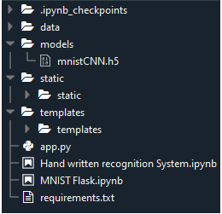

* We are building a Flask Application which needs  HTML pages stored in the templates folder and a python script app.py for server side scripting.
* The model is built in the notebook Hand written recognition system.ipynb
* We need the model which is saved and the saved model in this content is mnistCNN.h5
* The static folder will contain js and css files.
* The templates mainly used here are main.html and index6.html for showcasing the UI

**Prerequisites**

**To complete this project you should have the following software  and packages**

**Anaconda Navigator :**

Anaconda Navigator is a free and open-source distribution of the Python and R programming languages for data science and machine learning related applications. It can be installed on Windows, Linux, and macOS. Conda is an open-source, cross-platform,  package management system. Anaconda comes with so very nice tools like JupyterLab, Jupyter Notebook, QtConsole, Spyder, Glueviz, Orange, Rstudio, Visual Studio Code. For this project, we will be using Jupiter notebook and spyder.

**Understanding The Data**

ML depends heavily on data, without data, it is impossible for a machine to learn. It is the most crucial aspect that makes algorithm training possible. In Machine Learning projects, we need a training data set. It is the actual data set used to train the model for performing various actions. TensorFlow already has MNist Data set so there is no need to explicitly download or create Dataset

The MNSIT dataset contains ten classes: Digits from 0-9. Each digit is taken as a class

In this activity, let's load the data and understand the features of the data.

**Importing The Required Libraries**

Lets first import the libraries

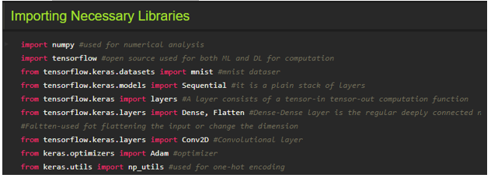

Importing the required libraries which are required for the model to run. The dataset for this model is imported from the Keras module.

The dataset contains ten classes: Digits from 0-9. Each digit is taken as a class

For a detail point of view on Keras and TensorFlow refer to the**link**[**here**](https://www.upgrad.com/blog/the-whats-what-of-keras-and-tensorflow/)**:**

**Loading The Data**

The dataset for this model is imported from the Keras module.

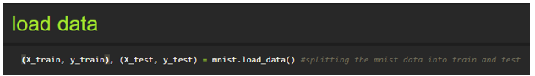

We split the data into train and test. Using the training dataset we train the model and the testing dataset is used to predict the results.

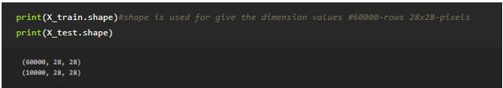

We are finding out the shape of X\_train and x\_test for better understanding. It lists out the dimensions of the data present in it.

in trainset, we have 60000 images, and in the test  set we have 10000 images

**Analyzing The Data**

Let's see the  Information of an image lying inside the x\_train variable

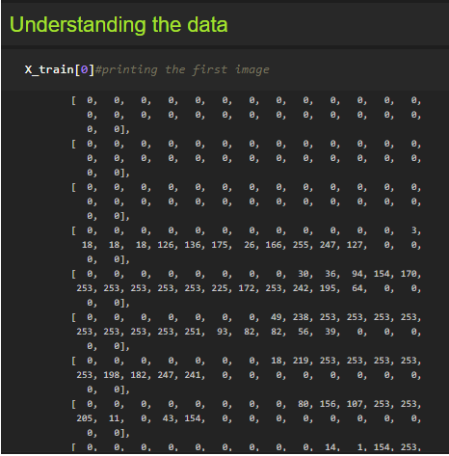

Basically, the pixel values range from 0-255. Here we are printing the first image pixel value which is index[0] of the training data. As you see it is displayed in the output.

With respect to this image, the  label of this image will e stored in y\_train let's see what is the label of this image by grabbing it from the y\_train variable

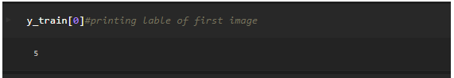

As we saw in the previous screenshot, we get to know that the pixel values are printed. Now here we are finding to which image the pixel values belong to. From the output displayed we get to know that the image is ‘5’.

Lets Plot the image on a graph using the Matplot library

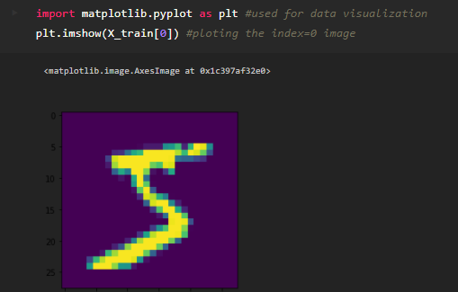

Matplotlib is a comprehensive library for creating static, animated, and interactive visualizations in Python. By using the Matplotlib library we are displaying the number ‘5’ in the form of an image for proper understanding.

**Note:** You can see the results by replacing the index number till 59999 as the train set has 60K images

**Reshaping The Data**

As we are using Deep learning neural network, the input for this network to get trained on should be of higher dimensional. Our dataset is having three-dimensional images so we have to reshape them too higher dimensions

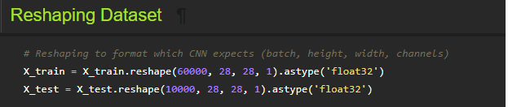

We are reshaping the dataset because we are building the model using CNN. As CNN needs four attributes batch, height, width, and channels we reshape the data.

### Applying One Hot Encoding

If you see our y\_train variable contains Labels representing the images containing in x\_train. AS these are numbers usually they can be considered as numerical or continuous data, but with respect to this project these Numbers are representing a set of class so these are to be represented as categorical data, and we need to binaries these categorical data  that's why we are  applying One Hot encoding for y\_train set

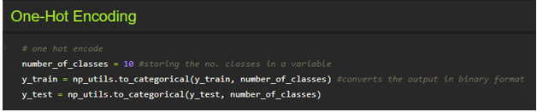

One hot encoding is a process by which categorical variables are converted into a form that could be provided to ML algorithms to do a better job in prediction. We apply One-Hot Encoding in order to convert the values into 0’s and 1’s. For a detailed point of view, look at this  [link](https://deeplizard.com/learn/video/v_4KWmkwmsU" \t "_blank)

Now let's see how   our label 5 is index 0 of y\_train is converted

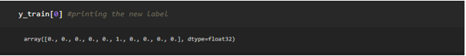

As we see the new the label is printed in the form of 0’s and 1’s and is of type float.

**Model Building**

This activity includes the following steps

* Initializing the model
* Adding CNN Layers
* Training and testing the model
* Saving the model

**Add CNN Layers**

Creating the model and adding the input, hidden, and output layers to it

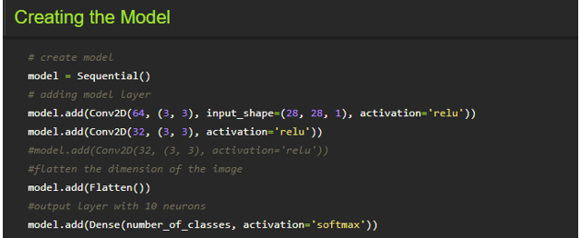

The Sequential model is a linear stack of layers. You can create a Sequential model by passing a list of layer instances to the

constructor:

**Compiling The Model**

With both the training data defined and model defined, it's time to configure the learning process. This is accomplished with a call to the compile () method of the Sequential model class. Compilation requires 3 arguments: an optimizer, a loss function, and a list of metrics.

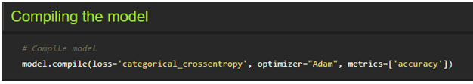

**Note:** In our project, we have 2 classes in the output, so the loss is binary\_crossentropy.

If you have more than two classes in output put “loss = categorical\_cross entropy”.

**Train The Model**

Now, let us train our model with our image dataset.

**Fit:** functions used to train a deep learning neural network

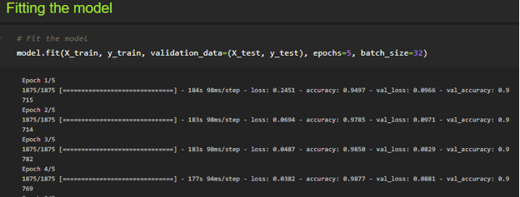

**Arguments:**

steps\_per\_epoch : it specifies the total number of steps taken from the generator as soon as one epoch is finished and the next epoch has started. We can calculate the value of steps\_per\_epoch as the total number of samples in your dataset divided by the batch size.

**Epochs:** an integer and number of epochs we want to train our model for.

**Validation\_data :**

* an inputs and targets list
* a generator
* inputs, targets, and sample\_weights list which can be used to evaluate the loss and metrics for any model after any epoch has ended.

**validation\_steps:**

only if the validation\_data is a generator then only this argument can be used. It specifies the total number of steps taken from the generator before it is stopped at every epoch and its value is calculated as the total number of validation data points in your dataset divided by the validation batch size.

**Observing The Metrics**

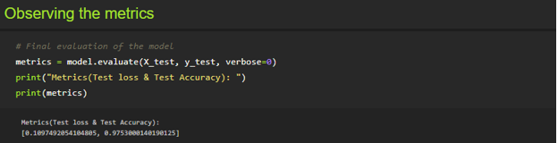

We here are printing the metrics which lists out the Test loss and Test accuracy

* Loss value implies how poorly or well a model behaves after each iteration of optimization.
* An accuracy metric is used to measure the algorithm's performance in an interpretable way.

**Test The Model**

Firstly we are slicing the x\_test data until the first four images. In the next step we the printing the predicted output.

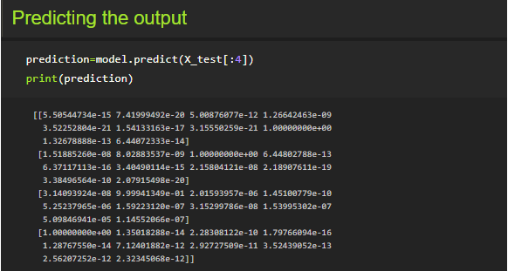

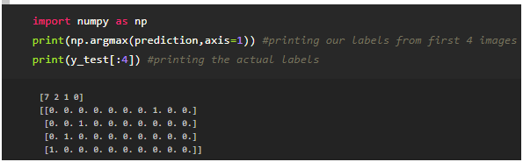

As we already predicted the input from the x\_test. According to that by using argmax function here we are printing the labels with high prediction values

**Observing The Metrics**



We here are printing the metrics which lists out the Test loss and Test accuracy

* Loss value implies how poorly or well a model behaves after each iteration of optimization.
* An accuracy metric is used to measure the algorithm's performance in an interpretable way.

**Test The Model**

Firstly we are slicing the x\_test data until the first four images. In the next step we the printing the predicted output.





As we already predicted the input from the x\_test. According to that by using argmax function here we are printing the labels with high prediction values

**Save The Model**

Your model is to be saved for future purposes. This saved model can also be integrated with an android application or web application in order to predict something.

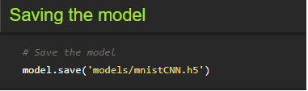

The model is saved with .h5 extension as follows:

An H5 file is a data file saved in the Hierarchical Data Format (HDF). It contains multidimensional arrays of scientific data.

**Test With Saved Model**

Now open another jupyter file and write the below code

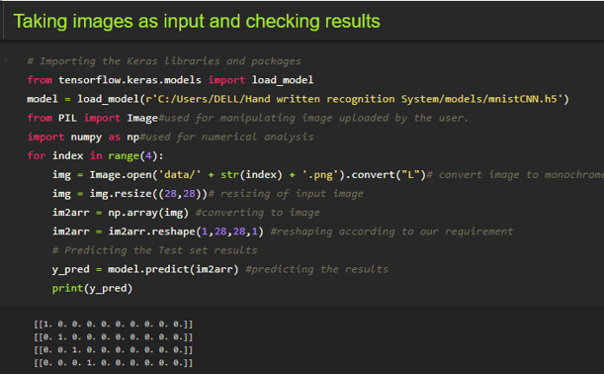

Firstly we are loading the model which was built. Then we are applying for a loop for the first four images and converting the image to the required format. Then we are resizing the input image, converting the image as per the CNN model and we are reshaping it according to the requirement. At last, we are predicting the result.

You can use predict\_classes for just predicting the class of an image

**Application Building**

In this section, we will be building a web application that is integrated into the model we built. A UI is provided for the uses where he has uploaded an image. The uploaded image is given to the saved model and prediction is showcased on the UI.

This section has the following tasks

* Building HTML Pages
* Building server-side script

**Create An HTML File**

* We use HTML to create the front end part of the web page.
* Here, we created 2 html pages- index.html, web.html.
* index.html displays home page.
* web.html accepts the values from the input and displays the prediction.
* For more information regarding HTML refer the link below

Please refer to the link for HTML code files

Let's see how our index.html file looks like

This is the main page which describes about the project and summarizes it.



Let's see how our web.html page looks like

This is the prediction page where we get to choose the image from our local system and predict the output.

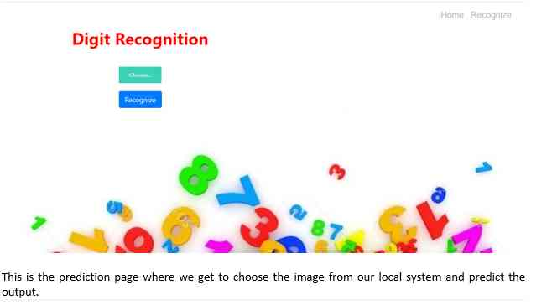

**Build Python Code (Part 1)**

**Let us build the flask file ‘app.py’ which is a web framework written in python for server-side scripting. Let’s see step by step procedure for building the backend application**.

* App starts running when the “\_\_name\_\_” constructor is called in main.
* render\_template is used to return HTML file.
* “GET” method is used to take input from the user.
* “POST” method is used to display the output to the user.

**Import Libraries:**

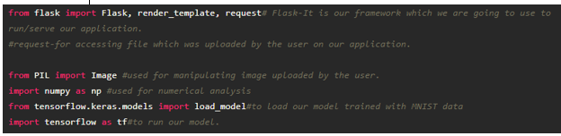

Libraries required for the app to run are to be imported.

**Routing to the html Page**

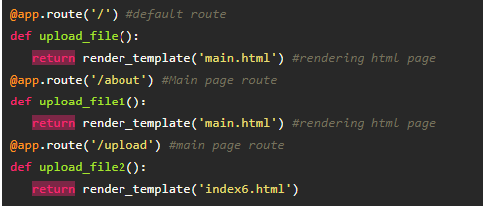

We are routing the app to the HTML templates which we want to render.

Firstly we are rendering the main.html template and from there we are navigating to our prediction page that is index6.html

**Returning the prediction on UI:**

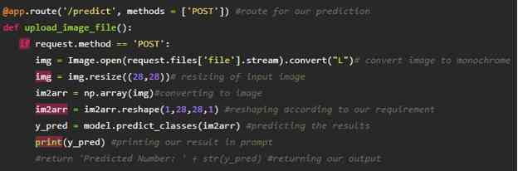

**Build Python Code (Part 2)**

Here the route for prediction is given and necessary steps are performed in order to get the predicted output.

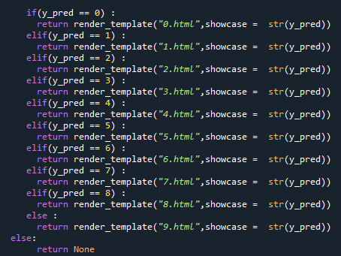

Necessary conditions are given according to the input classes and the app will be returning the templates according to that.

Main Function:

This function runs your app in a web browser

 Lastly, we run our app on the localhost. Here we are running it on localhost:8000

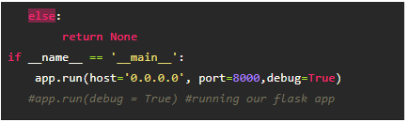

**Run The Application**

* Open anaconda prompt from the start menu
* Navigate to the folder where your python script is.
* Now type “python app.py” command

download (27).png

Navigate to the localhost where you can view your web page

**Upload an image and see the predicted output on UI your page and output looks like:**

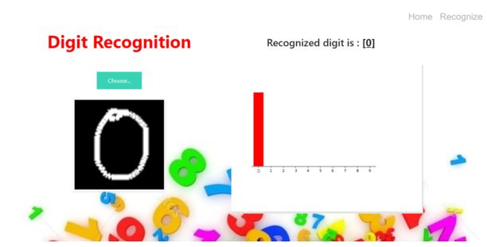

**Train The Model On IBM**

In this milestone, you will learn how to build Deep Learning Model Using the IBM cloud

**Register For IBM Cloud**

**To complete this project you must have an IBM account**

**IBM Account:**

* Please click [**here**](https://cloud.ibm.com/registration)to register for IBM
* Please click [**here**](https://cloud.ibm.com/login)to log in to IBM Account.

**Ideation Phase**

In this milestone you are expected to get started with the Ideation process.

**Literature Survey On The Selected Project & Information Gathering**

In this activity you are expected to gather/collect the relevant information on project use case, refer the existing solutions, technical papers, research publications etc.

**Prepare Empathy Map**

In this activity you are expected to prepare the empathy map canvas to capture the user Pains & Gains, Prepare list of problem statements.

**Ideation**

In this activity you are expected to list the ideas (at least 4 per each team member) by organizing the brainstorming session and prioritize the top 3 ideas based on the feasibility & importance.

**Project Design Phase – I**

From this milestone you will be starting the project design phase. You are expected to cover the activities given.

**Proposed Solution**

In this activity you are expected to prepare the proposed solution document, which includes the novelty, feasibility of idea, business model, social impact, scalability of solution, etc.

**Problem Solution Fit**

In this activity you are expected to prepare problem - solution fit document and submit for review.

**Solution Architecture**

In this activity you are expected to prepare solution architecture document and submit for review.

**Project Development Phase**

In this milestone you will start the project development and expected to perform the coding & solutioning, acceptance testing, performance testing based as per the sprint and submit them.

**Project Development - Delivery Of Sprint-1**

In this activity you are expected to develop & submit the developed code by testing it.

**Project Development - Delivery Of Sprint-2**

In this activity you are expected to develop & submit the developed code by testing it.

**Project Development - Delivery Of Sprint-3**

In this activity you are expected to develop & submit the developed code by testing it.

**Project Development - Delivery Of Sprint-4**

In this activity you are expected to develop & submit the developed code by testing it.